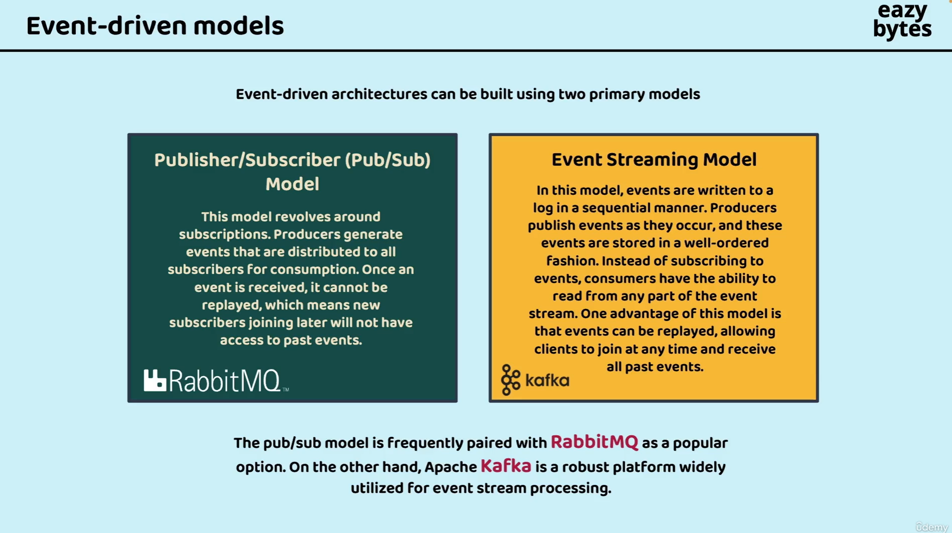

Difference between pub/sub and event driven model are:

Inside pub/sub model, we cannot replay the events or messages whenever we use message broker like Rabbitmq.

But in the recent versions of Rabbitmq, event streaming capabilities are also provided with Rabbitmq, we can also replay the events or messages. But still the majority of the people they uses Apache Kafka for event streaming scenarios because by the time Rabbitmq team realizes and implement the same Apache acquired most of the market.

Rabbitmq is an open source message broker, which is majorly used by most of the organizations.

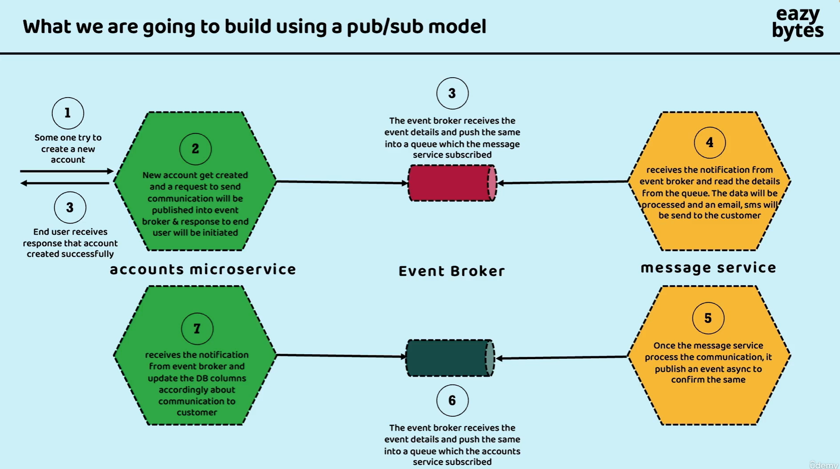

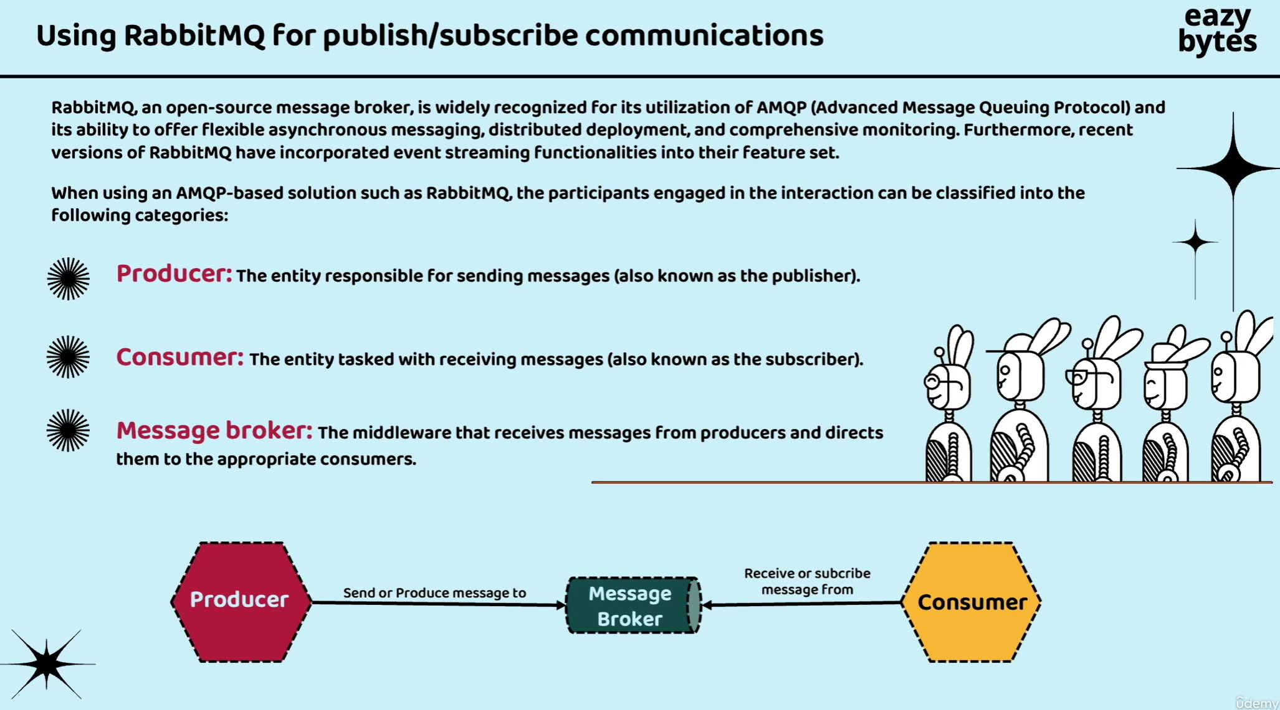

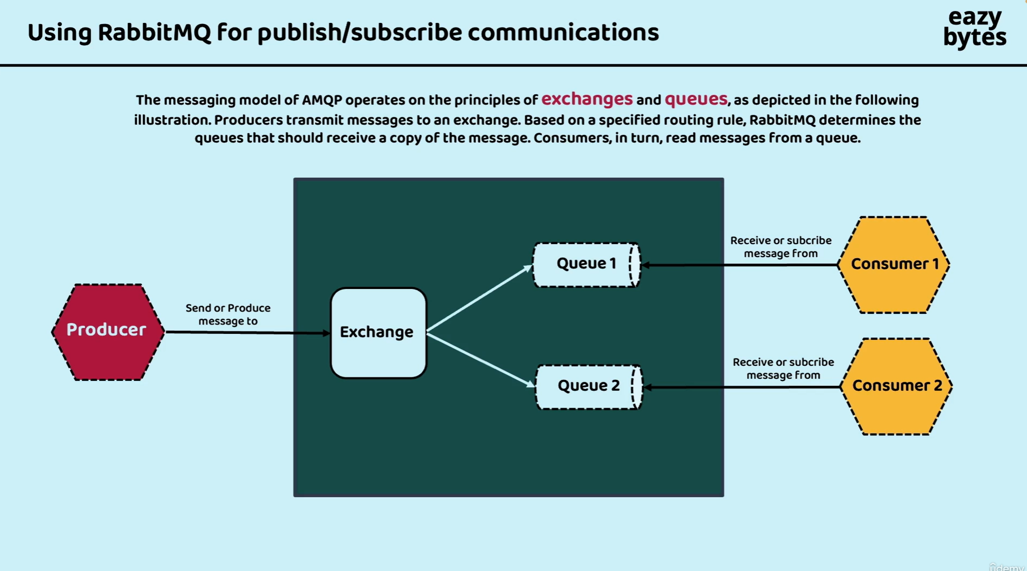

<https://www.rabbitmq.com/>

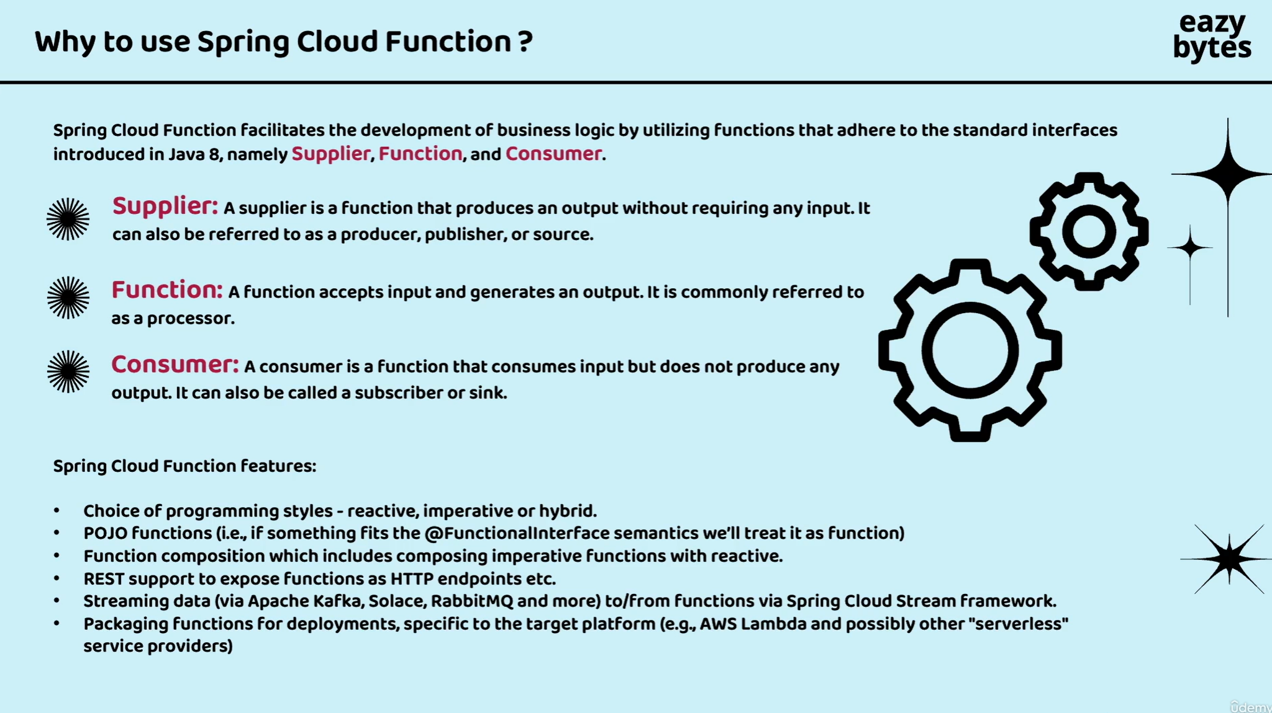

<https://spring.io/projects/spring-cloud-function>

<https://docs.spring.io/spring-cloud-function/docs/current/reference/html/spring-cloud-function.html#_programming_model>

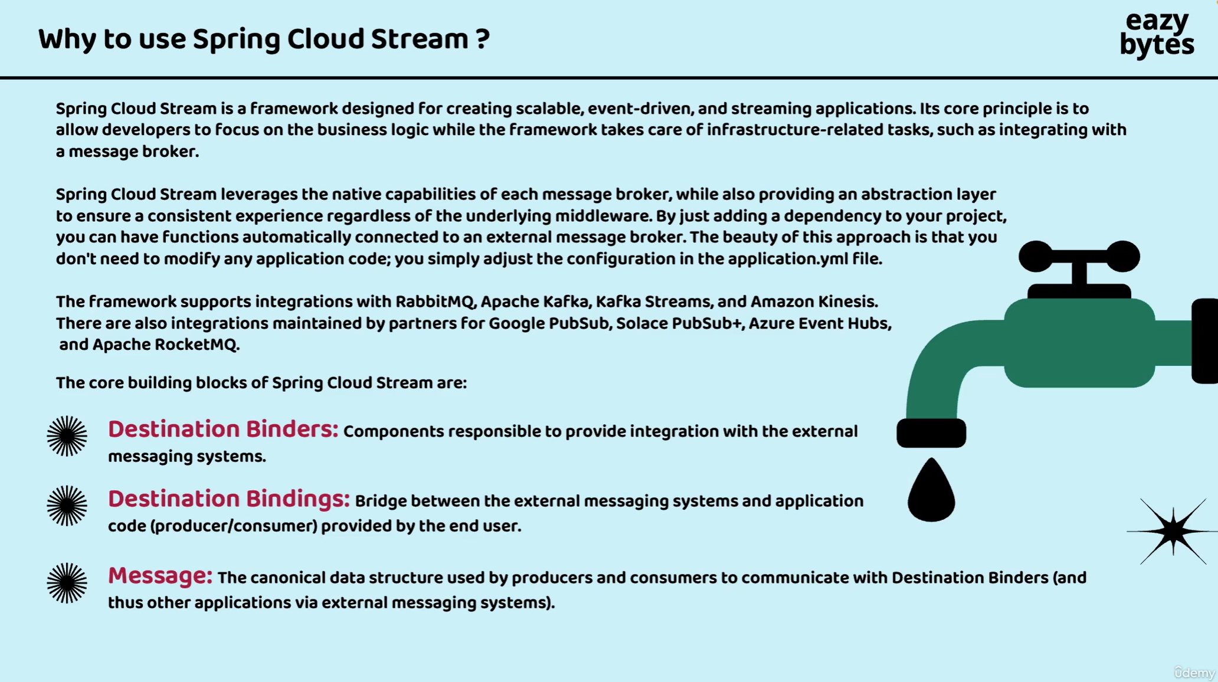

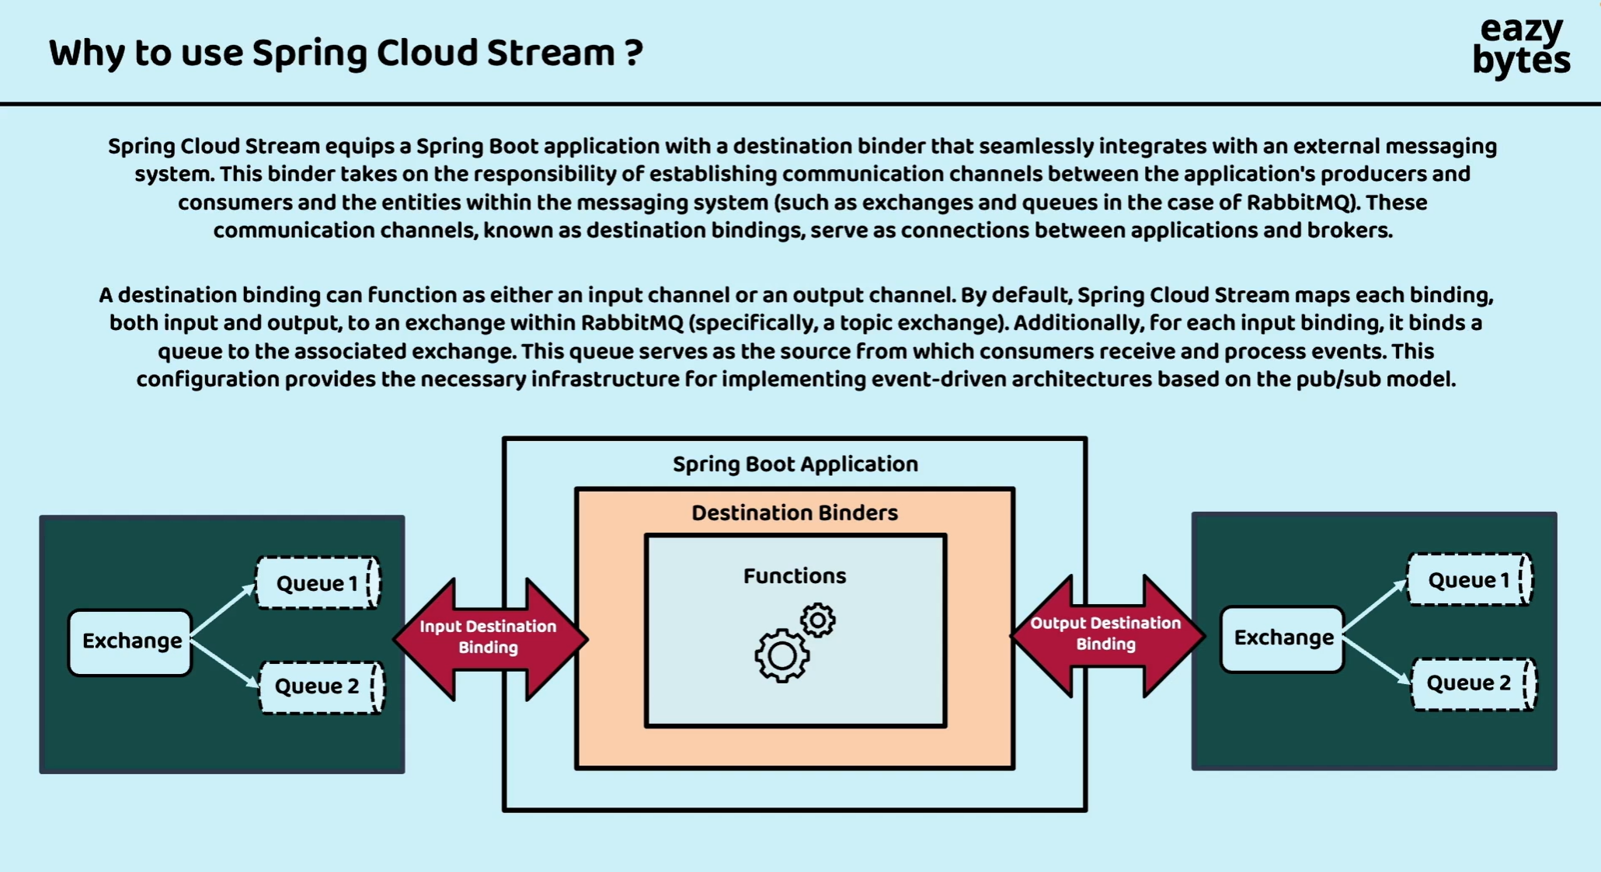

https://spring.io/projects/spring-cloud-stream

